PF LAB

Assignment 8

# NAME: Mehreen Fatima

# SAP ID:63255

# TASK 1:

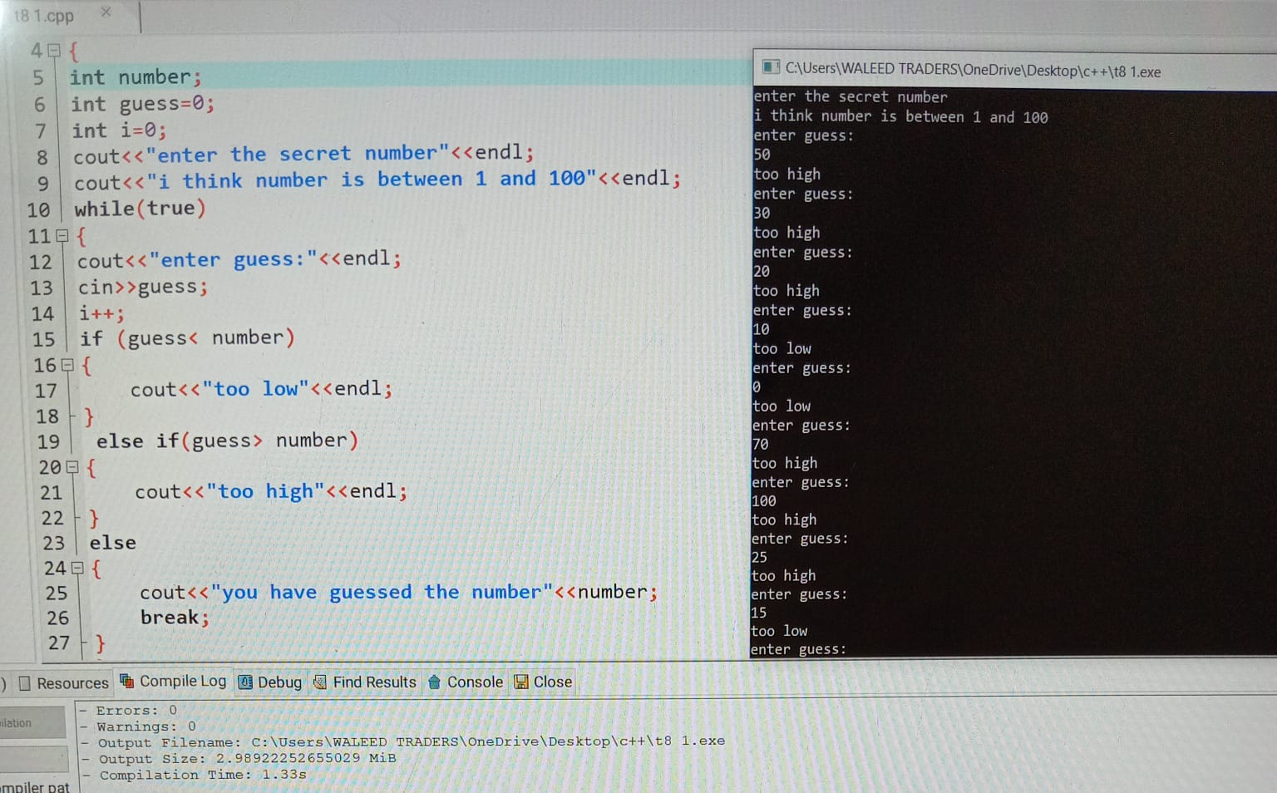

# TASK 2:

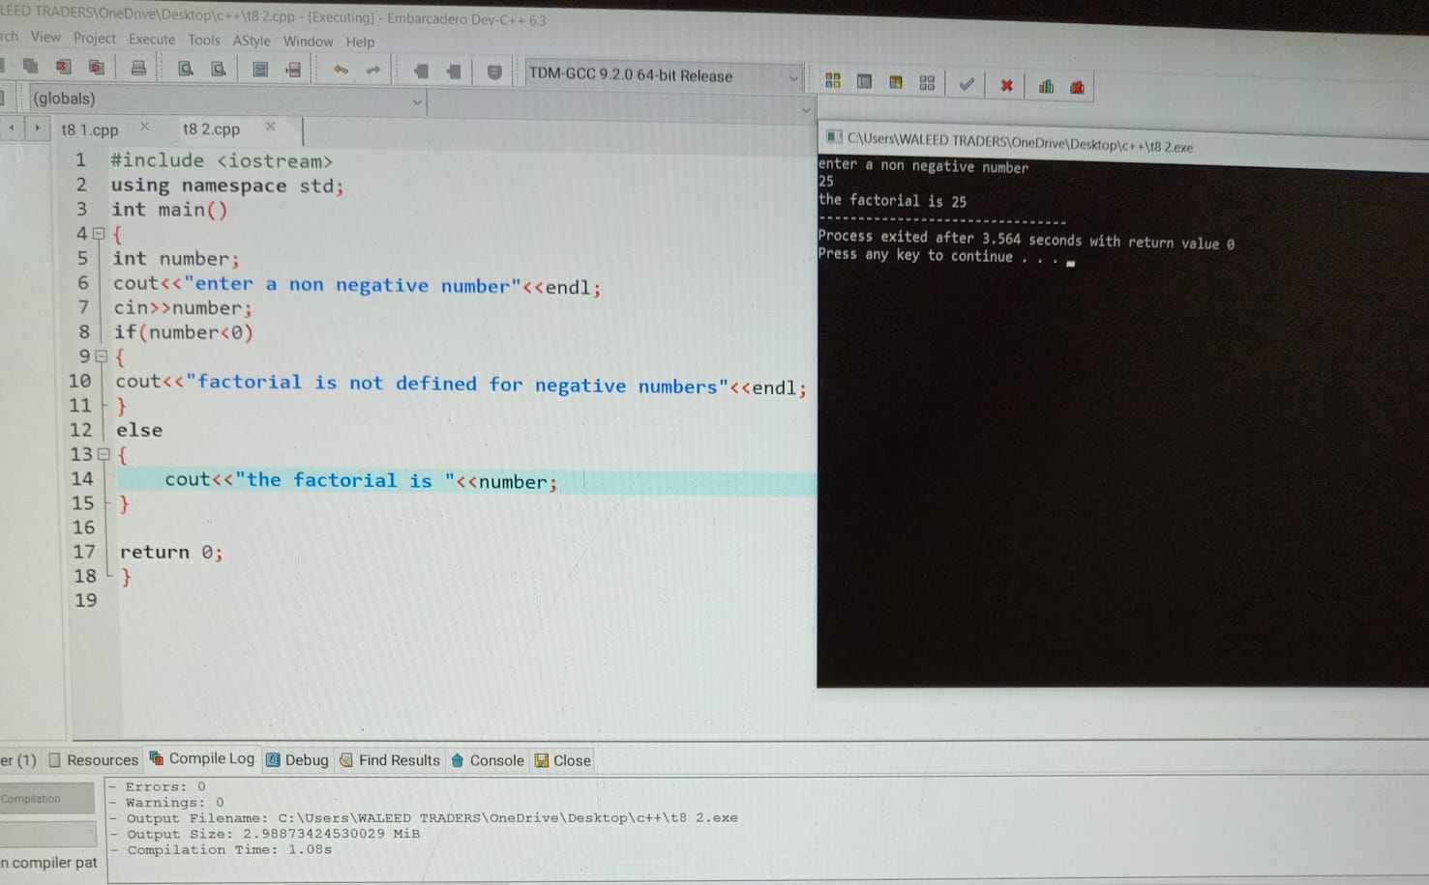

# TASK 3:

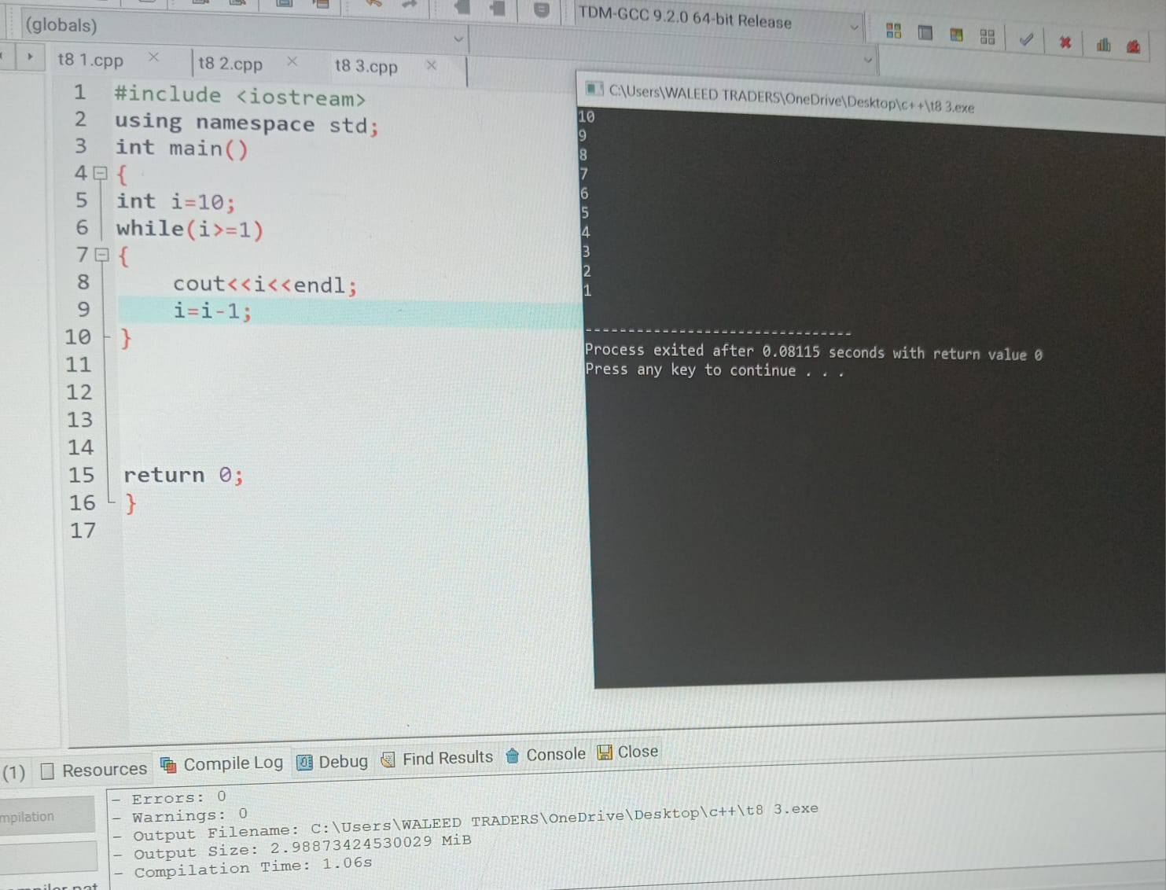

# TASK 4:

